**School Supply List-Room 105-Preschool**

* **1 Large backpack with complete change of clothes (including underwear and socks - for water or paint spills)**
* **2 Paper towels** [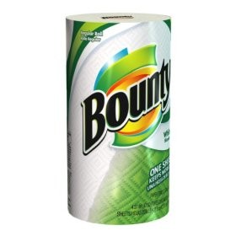](http://www.cuckooforcoupondeals.com/weekly/home-depot-weekly/home-depot-bounty-paper-towels-just-0-06/)

**[1 sanitizer](https://www.officedepot.com/a/products/514510/Purell-Instant-Hand-Sanitizer-8-Oz/" \t "_blank)**[[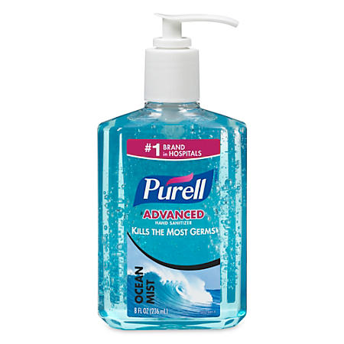](https://www.officedepot.com/a/products/514510/Purell-Instant-Hand-Sanitizer-8-Oz/)](https://www.officedepot.com/a/products/514510/Purell-Instant-Hand-Sanitizer-8-Oz/" \t "_blank)

* **1 boxes of 5 oz. Dixie paper cups (small)** [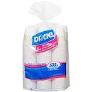](http://www.google.com/imgres?imgurl=http://ecx.images-amazon.com/images/I/41CHiBvUobL._SS500_.jpg&imgrefurl=http://www.oneshetwoshe.com/2010/05/homemade-popsicles-molds-recipes.html&usg=__QEswPsiSKjEUKlujOlJJ4hug2h0=&h=500&w=500&sz=28&hl=en&start=5&zoom=1&tbnid=chtB3mErudzqMM:&tbnh=130&tbnw=130&ei=gNVAUJSoN-PBygHxhoGoBQ&prev=/search?q=small+dixie+cups&um=1&hl=en&safe=strict&gbv=2&tbm=isch&um=1&itbs=1)
* **3 Clorox Disinfecting Wipes for tables and chairs** [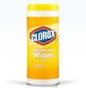](http://www.google.com/imgres?imgurl=http://www.mamas-spot.com/image.axd?picture=2011/8/Target-Clorox-Disinfecting-Wipes-139-7ce1cf4f169a.jpg&imgrefurl=http://www.mamas-spot.com/post/2011/08/21/Target-Clorox-Disinfecting-Wipes-Only-139.aspx&usg=__SBYMCnkGDNvTWWX62gD01baqk5s=&h=258&w=254&sz=10&hl=en&start=4&zoom=1&tbnid=iPevDLRnTv7cYM:&tbnh=112&tbnw=110&ei=DNRAUO7FLqflyAHJ1IGQBw&prev=/search?q=disinfecting+wipes&um=1&hl=en&safe=strict&sa=N&gbv=2&tbm=isch&um=1&itbs=1)
* **2 container of “wet ones” hand wipes** [](http://www.google.com/imgres?imgurl=http://www.polyvore.com/cgi/img-thing?.out=jpg&size=l&tid=58088471&imgrefurl=http://www.polyvore.com/wet_ones_antibacterial_hand_wipes/thing?id=58088471&usg=__0DhmoZc_rgG1uiy333OQK33yiyk=&h=300&w=300&sz=18&hl=en&start=24&zoom=1&tbnid=CCRb5omJYkO5CM:&tbnh=116&tbnw=116&ei=E9VAUNnSHsytygG-lYGoDg&prev=/search?q=wet+ones+hand+wipes&start=20&um=1&hl=en&safe=strict&sa=N&gbv=2&tbm=isch&um=1&itbs=1)
* **1 box of tissues for runny noses** [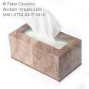](http://www.google.com/imgres?imgurl=http://www.acclaimimages.com/_gallery/_images_n300/0061-0702-2817-4316_box_tissues_on_white_background.jpg&imgrefurl=http://www.acclaimimages.com/_gallery/_image_pages/0061-0702-2817-4316.html&usg=__i30vXfUp_gq0QK0lqR94pcCT08c=&h=300&w=300&sz=16&hl=en&start=8&zoom=1&tbnid=Jhv-cmUlMMqMhM:&tbnh=116&tbnw=116&ei=NtVAUPvUMoPfyAHahoCwBw&prev=/search?q=box+of+tissues&um=1&hl=en&safe=strict&gbv=2&tbm=isch&um=1&itbs=1)
* **1 bottle of antibacterial hand soap** [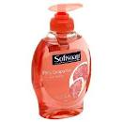](http://www.google.com/imgres?imgurl=http://store.iuneeds.com/images/hand_soap.jpg&imgrefurl=http://store.iuneeds.com/index.php?main_page=product_info&cPath=62_67&products_id=631&usg=__2amAAz3yJXDwe7AS0pcN97n0RM8=&h=500&w=500&sz=141&hl=en&start=2&zoom=1&tbnid=yRs4JT62VhaYnM:&tbnh=130&tbnw=130&ei=UtVAUPekH6yayQGVloDIBQ&prev=/search?q=hand+soap&um=1&hl=en&safe=strict&gbv=2&tbm=isch&um=1&itbs=1)
* **1 pocket folder - plastic**[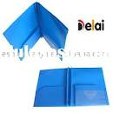](http://www.google.com/imgres?imgurl=http://www.lulusoso.com/upload/20120309/2_pockets_plastic_file_folder.jpg&imgrefurl=http://www.lulusoso.com/products/Plastic-Portfolio-Folder.html&usg=__nxMTbeRoLwBz94fq_ps9G20PlpI=&h=500&w=500&sz=24&hl=en&start=76&zoom=1&tbnid=O-mcs2hWRC2KIM:&tbnh=130&tbnw=130&ei=n9ZAULCzLcnWyQGJ0oCoBQ&prev=/search?q=folder+plastic&start=60&um=1&hl=en&safe=strict&sa=N&gbv=2&tbm=isch&um=1&itbs=1)
* **1 dry erase markers pack**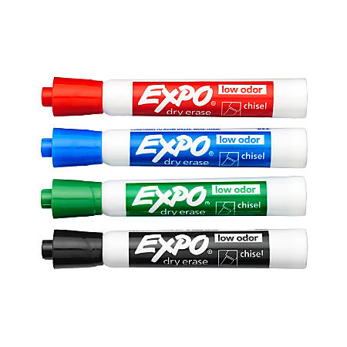
* **1watercolor paint** [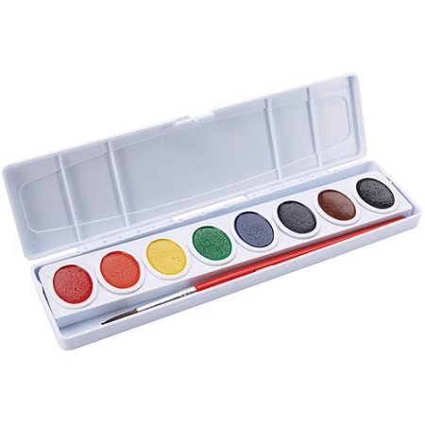](https://www.walmart.com/ip/Prang-Watercolor-Paint-Cakes-Assorted-Colors-8-pkg/14881911)
* **1 package of stickers** [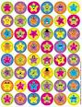](http://www.google.com/imgres?imgurl=http://www.smileyme.com/stickers/smile_face_stickers/stickers_star_smiles.gif&imgrefurl=http://www.smileyme.com/stickers_happy_face_stickers_smiley_stickers_face_stickers_smile.asp&usg=__yf68icvgnYZxz6YDXmcDxzlxM9w=&h=300&w=231&sz=38&hl=en&start=8&zoom=1&tbnid=qYXaBu3nFYGK5M:&tbnh=116&tbnw=89&ei=ltdAUIPaC8fryAH1tYGgCg&prev=/search?q=stickers&um=1&hl=en&safe=strict&gbv=2&tbm=isch&um=1&itbs=1)
* **1 Large set of thick writing pencils** [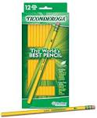](http://www.google.com/imgres?imgurl=http://www.toolking.com/media/catalog/product/T/i/Ticonderoga_13812_12_Count_number_2_Yellow_Wood_Pencils.jpg&imgrefurl=http://www.toolking.com/1/tool_king_tkpencil_10_construction_pencils_10_pack_1051106932.php&usg=__19ohN0pxQEDcTiwW_B_1Sm-An-U=&h=2080&w=1724&sz=1313&hl=en&start=11&zoom=1&tbnid=xjoX4_Um5BDB7M:&tbnh=150&tbnw=124&ei=fthAUIqUJYH5ygHhqIH4DA&prev=/search?q=large+set+of+pencils+yellow+ticonderoga&um=1&hl=en&safe=strict&gbv=2&tbm=isch&um=1&itbs=1)
* **1 Subject notebook (70 sheets Ring Binder)** [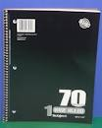](http://www.google.com/imgres?imgurl=http://walker.district65.net/teachers/jaddaouin/00136FD1-011F5307.2/sprial_notebook.jpg&imgrefurl=http://walker.district65.net/teachers/jaddaouin/supply%20lists&usg=__pXaobyFeMd8SXNxgMGnfeKIcbqc=&h=500&w=400&sz=153&hl=en&start=3&zoom=1&tbnid=5qHUsJMgjg4uPM:&tbnh=130&tbnw=104&ei=rthAUODZN8XSqgGgzYDACg&prev=/search?q=70+page+spiral+notebooks&um=1&hl=en&safe=strict&gbv=2&tbm=isch&um=1&itbs=1)
* **1 Large Ziploc Bags/ 1 Small Ziploc Bags** [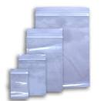](http://www.google.com/imgres?imgurl=http://4.bp.blogspot.com/-rf4_hswF30E/Te5PjYs8ILI/AAAAAAAAAFo/G3nciZvmEko/s1600/20105115410580.jpg&imgrefurl=http://bathtagreby.blogspot.com/2011/06/what-to-carry-on-road.html&usg=__smx9mTH2tWy0woGPenE6YI7O8Mw=&h=510&w=510&sz=29&hl=en&start=4&zoom=1&tbnid=DCYtnEIDaoYIPM:&tbnh=131&tbnw=131&ei=y9hAUIi4KsGJywGymIGwCQ&prev=/search?q=small+ziplock+bags&um=1&hl=en&safe=strict&gbv=2&tbm=isch&um=1&itbs=1)

**Lista de útiles - Salón 105-Prescolar**

* **1 mochila con un cambio de ropa (incluyendo calzones y calcetines – para derrames de agua o pintura)**
* **2 rollos de papel** [](http://www.cuckooforcoupondeals.com/weekly/home-depot-weekly/home-depot-bounty-paper-towels-just-0-06/)
  + - * **[1 desinfectante de manos](https://www.officedepot.com/a/products/514510/Purell-Instant-Hand-Sanitizer-8-Oz/" \t "_blank)**[[](https://www.officedepot.com/a/products/514510/Purell-Instant-Hand-Sanitizer-8-Oz/)](https://www.officedepot.com/a/products/514510/Purell-Instant-Hand-Sanitizer-8-Oz/" \t "_blank)
* **1caja de vasos Dixie de 5 oz. (pequeños)** [](http://www.google.com/imgres?imgurl=http://ecx.images-amazon.com/images/I/41CHiBvUobL._SS500_.jpg&imgrefurl=http://www.oneshetwoshe.com/2010/05/homemade-popsicles-molds-recipes.html&usg=__QEswPsiSKjEUKlujOlJJ4hug2h0=&h=500&w=500&sz=28&hl=en&start=5&zoom=1&tbnid=chtB3mErudzqMM:&tbnh=130&tbnw=130&ei=gNVAUJSoN-PBygHxhoGoBQ&prev=/search?q=small+dixie+cups&um=1&hl=en&safe=strict&gbv=2&tbm=isch&um=1&itbs=1)
* **3 botes de toallas desinfectantes Clorox para mesas y sillas** [](http://www.google.com/imgres?imgurl=http://www.mamas-spot.com/image.axd?picture=2011/8/Target-Clorox-Disinfecting-Wipes-139-7ce1cf4f169a.jpg&imgrefurl=http://www.mamas-spot.com/post/2011/08/21/Target-Clorox-Disinfecting-Wipes-Only-139.aspx&usg=__SBYMCnkGDNvTWWX62gD01baqk5s=&h=258&w=254&sz=10&hl=en&start=4&zoom=1&tbnid=iPevDLRnTv7cYM:&tbnh=112&tbnw=110&ei=DNRAUO7FLqflyAHJ1IGQBw&prev=/search?q=disinfecting+wipes&um=1&hl=en&safe=strict&sa=N&gbv=2&tbm=isch&um=1&itbs=1)
* **2 botes de toallas húmedas “wet ones”** [](http://www.google.com/imgres?imgurl=http://www.polyvore.com/cgi/img-thing?.out=jpg&size=l&tid=58088471&imgrefurl=http://www.polyvore.com/wet_ones_antibacterial_hand_wipes/thing?id=58088471&usg=__0DhmoZc_rgG1uiy333OQK33yiyk=&h=300&w=300&sz=18&hl=en&start=24&zoom=1&tbnid=CCRb5omJYkO5CM:&tbnh=116&tbnw=116&ei=E9VAUNnSHsytygG-lYGoDg&prev=/search?q=wet+ones+hand+wipes&start=20&um=1&hl=en&safe=strict&sa=N&gbv=2&tbm=isch&um=1&itbs=1)
* **1 caja de Kleenex** [](http://www.google.com/imgres?imgurl=http://www.acclaimimages.com/_gallery/_images_n300/0061-0702-2817-4316_box_tissues_on_white_background.jpg&imgrefurl=http://www.acclaimimages.com/_gallery/_image_pages/0061-0702-2817-4316.html&usg=__i30vXfUp_gq0QK0lqR94pcCT08c=&h=300&w=300&sz=16&hl=en&start=8&zoom=1&tbnid=Jhv-cmUlMMqMhM:&tbnh=116&tbnw=116&ei=NtVAUPvUMoPfyAHahoCwBw&prev=/search?q=box+of+tissues&um=1&hl=en&safe=strict&gbv=2&tbm=isch&um=1&itbs=1)
* **1 botella de jabón antibacterial para lavar manos** [](http://www.google.com/imgres?imgurl=http://store.iuneeds.com/images/hand_soap.jpg&imgrefurl=http://store.iuneeds.com/index.php?main_page=product_info&cPath=62_67&products_id=631&usg=__2amAAz3yJXDwe7AS0pcN97n0RM8=&h=500&w=500&sz=141&hl=en&start=2&zoom=1&tbnid=yRs4JT62VhaYnM:&tbnh=130&tbnw=130&ei=UtVAUPekH6yayQGVloDIBQ&prev=/search?q=hand+soap&um=1&hl=en&safe=strict&gbv=2&tbm=isch&um=1&itbs=1)
* **1 carpeta con bolsillos - plástico**[](http://www.google.com/imgres?imgurl=http://www.lulusoso.com/upload/20120309/2_pockets_plastic_file_folder.jpg&imgrefurl=http://www.lulusoso.com/products/Plastic-Portfolio-Folder.html&usg=__nxMTbeRoLwBz94fq_ps9G20PlpI=&h=500&w=500&sz=24&hl=en&start=76&zoom=1&tbnid=O-mcs2hWRC2KIM:&tbnh=130&tbnw=130&ei=n9ZAULCzLcnWyQGJ0oCoBQ&prev=/search?q=folder+plastic&start=60&um=1&hl=en&safe=strict&sa=N&gbv=2&tbm=isch&um=1&itbs=1)
* **1 paquete de marcadores dry erase** 
* **1 estuche de pinturas** [](https://www.walmart.com/ip/Prang-Watercolor-Paint-Cakes-Assorted-Colors-8-pkg/14881911)
* **1 paquete de calcomanías** [](http://www.google.com/imgres?imgurl=http://www.smileyme.com/stickers/smile_face_stickers/stickers_star_smiles.gif&imgrefurl=http://www.smileyme.com/stickers_happy_face_stickers_smiley_stickers_face_stickers_smile.asp&usg=__yf68icvgnYZxz6YDXmcDxzlxM9w=&h=300&w=231&sz=38&hl=en&start=8&zoom=1&tbnid=qYXaBu3nFYGK5M:&tbnh=116&tbnw=89&ei=ltdAUIPaC8fryAH1tYGgCg&prev=/search?q=stickers&um=1&hl=en&safe=strict&gbv=2&tbm=isch&um=1&itbs=1)
* **1 paquete de lápices gruesos** [](http://www.google.com/imgres?imgurl=http://www.toolking.com/media/catalog/product/T/i/Ticonderoga_13812_12_Count_number_2_Yellow_Wood_Pencils.jpg&imgrefurl=http://www.toolking.com/1/tool_king_tkpencil_10_construction_pencils_10_pack_1051106932.php&usg=__19ohN0pxQEDcTiwW_B_1Sm-An-U=&h=2080&w=1724&sz=1313&hl=en&start=11&zoom=1&tbnid=xjoX4_Um5BDB7M:&tbnh=150&tbnw=124&ei=fthAUIqUJYH5ygHhqIH4DA&prev=/search?q=large+set+of+pencils+yellow+ticonderoga&um=1&hl=en&safe=strict&gbv=2&tbm=isch&um=1&itbs=1)
* **1 libreta (70 hojas)** [](http://www.google.com/imgres?imgurl=http://walker.district65.net/teachers/jaddaouin/00136FD1-011F5307.2/sprial_notebook.jpg&imgrefurl=http://walker.district65.net/teachers/jaddaouin/supply%20lists&usg=__pXaobyFeMd8SXNxgMGnfeKIcbqc=&h=500&w=400&sz=153&hl=en&start=3&zoom=1&tbnid=5qHUsJMgjg4uPM:&tbnh=130&tbnw=104&ei=rthAUODZN8XSqgGgzYDACg&prev=/search?q=70+page+spiral+notebooks&um=1&hl=en&safe=strict&gbv=2&tbm=isch&um=1&itbs=1)
* **1 caja de bolsas grande y pequeñas Ziploc** [](http://www.google.com/imgres?imgurl=http://4.bp.blogspot.com/-rf4_hswF30E/Te5PjYs8ILI/AAAAAAAAAFo/G3nciZvmEko/s1600/20105115410580.jpg&imgrefurl=http://bathtagreby.blogspot.com/2011/06/what-to-carry-on-road.html&usg=__smx9mTH2tWy0woGPenE6YI7O8Mw=&h=510&w=510&sz=29&hl=en&start=4&zoom=1&tbnid=DCYtnEIDaoYIPM:&tbnh=131&tbnw=131&ei=y9hAUIi4KsGJywGymIGwCQ&prev=/search?q=small+ziplock+bags&um=1&hl=en&safe=strict&gbv=2&tbm=isch&um=1&itbs=1)